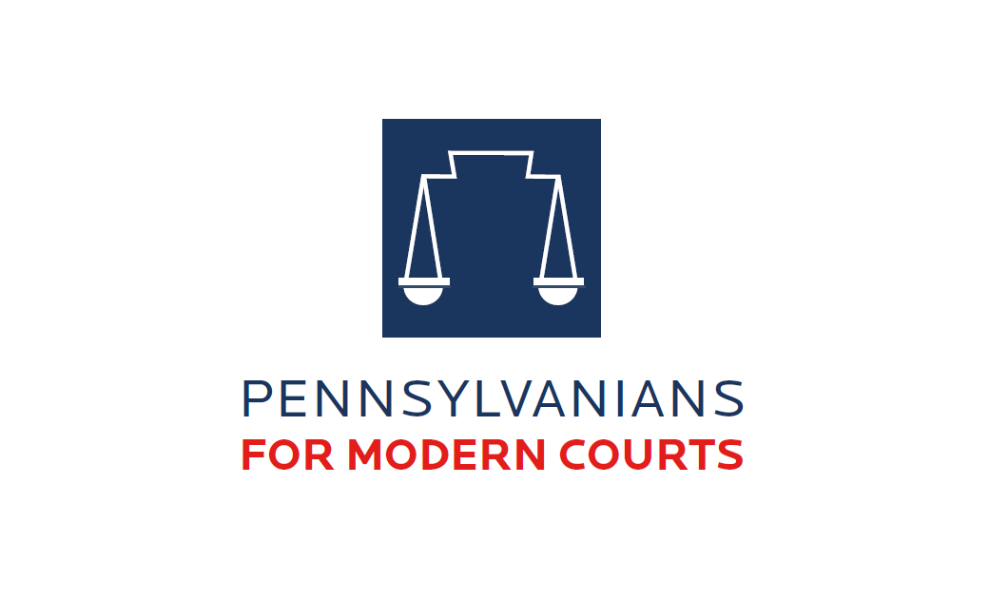

Pennsylvanians for Modern Courts is pleased to announce our 2025 Law Student Writing Competition topic sponsored by Faegre Drinker.

In so doing, PMC recognizes the importance of excellence in legal analysis and writing skills and seeks to award a student enrolled in an ABA-approved Pennsylvania-area law school for authoring a top-quality Competition submission.

The following information is provided to encourage your participation in the Competition.

**ELIGIBILITY**

This Competition is open to full- and part-time law students who are in their second or third year of study during the 2024-25 academic year at one of the following institutions: Villanova University Charles Widger School of Law, Rutgers Law School, University of Pittsburgh School of Law, Drexel University – Thomas R. Kline School of Law, Penn State Dickinson Law, Penn State Law, Thomas R. Kline School of Law of Duquesne University, Temple University Beasley School of Law, University of Pennsylvania Carey Law School, Delaware Law School – Widener University, Widener University Commonwealth Law School. Students must be in good standing at their institutions.

The submission may not have been published previously, although it may have been prepared in connection with a law school course or for a law journal. The submission also may not have been submitted for any other competition during the time when it is under consideration for PMC’s Competition, until after the time when awards are announced. The submission must be the work of one author alone (joint submissions will not be considered), and the author must certify that the submission has been prepared without substantial editing from others and without the use of AI.

**TOPIC**: ***What role, if any, should Artificial Intelligence have in jury selection and what would be the advantages and disadvantages of such use?***  **Candidates may submit a law review article** **quality submission of 2000-2500 words.**

**AWARDS:** The author of the First-Place submission will receive a cash award of $3,000, the publication of the winning submission. The winner of the First-Place award will be publicly presented with the award at PMC’s Spring Benefit in Pittsburgh in person or virtually in May 2025.

## **Past Winners**

2024 - Randy R. Goldson, Temple University Beasley School of Law School '24

2023 - Anthony Jessel, University of Pittsburgh School of Law '23

2022 - Constance Hope Long, Rutgers Law School '22

2021 - Apratim Vidyarthi, University of Pennsylvania Carey Law School '22

2020 - Jessica Rizzo, University of Pennsylvania Carey Law School '21

2019 - Zane Podsobinski, Duquesne University School of Law '19

2017 - Christina Gallagher, Penn State Law '17

**(To view winning essays, go to:** [**www.pmconline.org)**](https://www.pmconline.org/law-student-writing-competition)