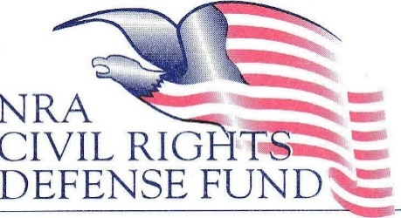

**ATTENTION**

**ALL LAW STUDENTS**

**The NRA Civil Rights Defense Fund proudly announces**

**2025 Law Student Second Amendment Research and Writing Competition**

**WHO: Any law student currently enrolled in an ABA Accredited law school**

**WHAT: Research and write a scholarly article, suitable for publication*, regarding a cutting edge Second Amendment issue.**

**WHEN: Articles must be submitted on or before March 1, 2025**

**WHY: $10,000 – First Place $7,000 – Second Place $3,000 Third Place**

**(and the possibility of being published*)**

**HOW: Send an email to** [nracrdf_lawschoolcontest@nrahq.org](mailto:nracrdf_lawschoolcontest@nrahq.org) **to request an entry packet.**

**\*Law students entering the competition are encouraged to contact and work with various law reviews and other law-related professional journals to attempt to have your article published.**