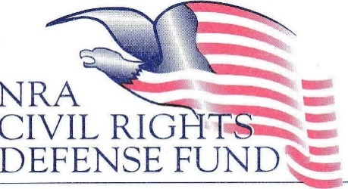

**LAW STUDENT RESEARCH AND WRITING COMPETITION**

**Background:**

On June 23, 2022, the United States Supreme Court rendered its long-awaited opinion in *New York State Rifle and Pistol Association v. Bruen,* 142 S. Ct. 2111 (2022), soundly rejecting balancing tests—such as the Intermediate Scrutiny Test adopted by many Circuits and many state courts—and adopted an entirely new test for analyzing Second Amendment cases.

While *Bruen* answered many questions necessary for Second Amendment jurisprudence, *Bruen* alsoleft many questions unanswered. Your assignment is to address one of those unanswered questions.

**Question Presented:**

*On June 23, 2022, the United States Supreme Court rendered its opinion in New York State Rifle and Pistol Association v. Bruen, 142 S. Ct. 2111 (2022), soundly rejecting balancing tests—such as the Intermediate Scrutiny Test—when analyzing Second Amendment challenges to firearms regulations.  The Supreme Court adopted an entirely new test for analyzing Second Amendment cases based on history, text, and tradition.  In light of the Bruen decision, does the prohibition found in 18 U.S.C. '922(g)(5) violate the Second Amendment?*

*18 U.S.C. '922(g)(5) provides, in pertinent part, that “it shall be unlawful for any person ...”*

*(5)     who, being an alien—*

*(A)     is illegally or unlawfully in the United States; or*

*(B)     except as provided in subsection (y)(2), has been admitted to the United States under a nonimmigrant visa ...;*

*to ... possess ... any firearm or ammunition.”*

**Instructions:**

Your task is to write and submit a unique and original written article, suitable for publication in a scholarly journal. Submissions must not exceed 12,000 words, including both text and notes. Citations shall conform to *THE BLUE BOOK: A UNIFORM SYSTEM OF CITATION.* Your submission is to be typed double spaced, in Times New Roman 12-point typeface, including notes. You may choose to use footnotes or endnotes.

Your completed submission must be received electronically as a PDF by the NRA Civil Rights Defense Fund at [nracrdf_lawschoolcontest@nrahq.org](mailto:nracrdf_lawschoolcontest@nrahq.org) on or before March 1, 2025.