**FIFTH ANNUAL JUDGE SAMUEL G. DESIMONE**

**MEMORIAL LEGAL WRITING COMPETITION 2024-2025**

**ELIGIBILITY:** The Judge Samuel G. DeSimone Legal Writing Competition is open to full-time and part-time law students who are enrolled in the 2024-2025 academic year in an accredited Law School. Students must reside in Burlington, Ocean, Atlantic, Cape May Cumberland, Salem, Gloucester, or Camden counties. Students must be or have been in good standing at their institutions. The submission must be original writings and may not have been previously published in a law review or journal. The submission also may not have been submitted for any other competition during the time when it is under consideration for this competition. The submission must be the work of one author alone; joint submissions will not be considered.

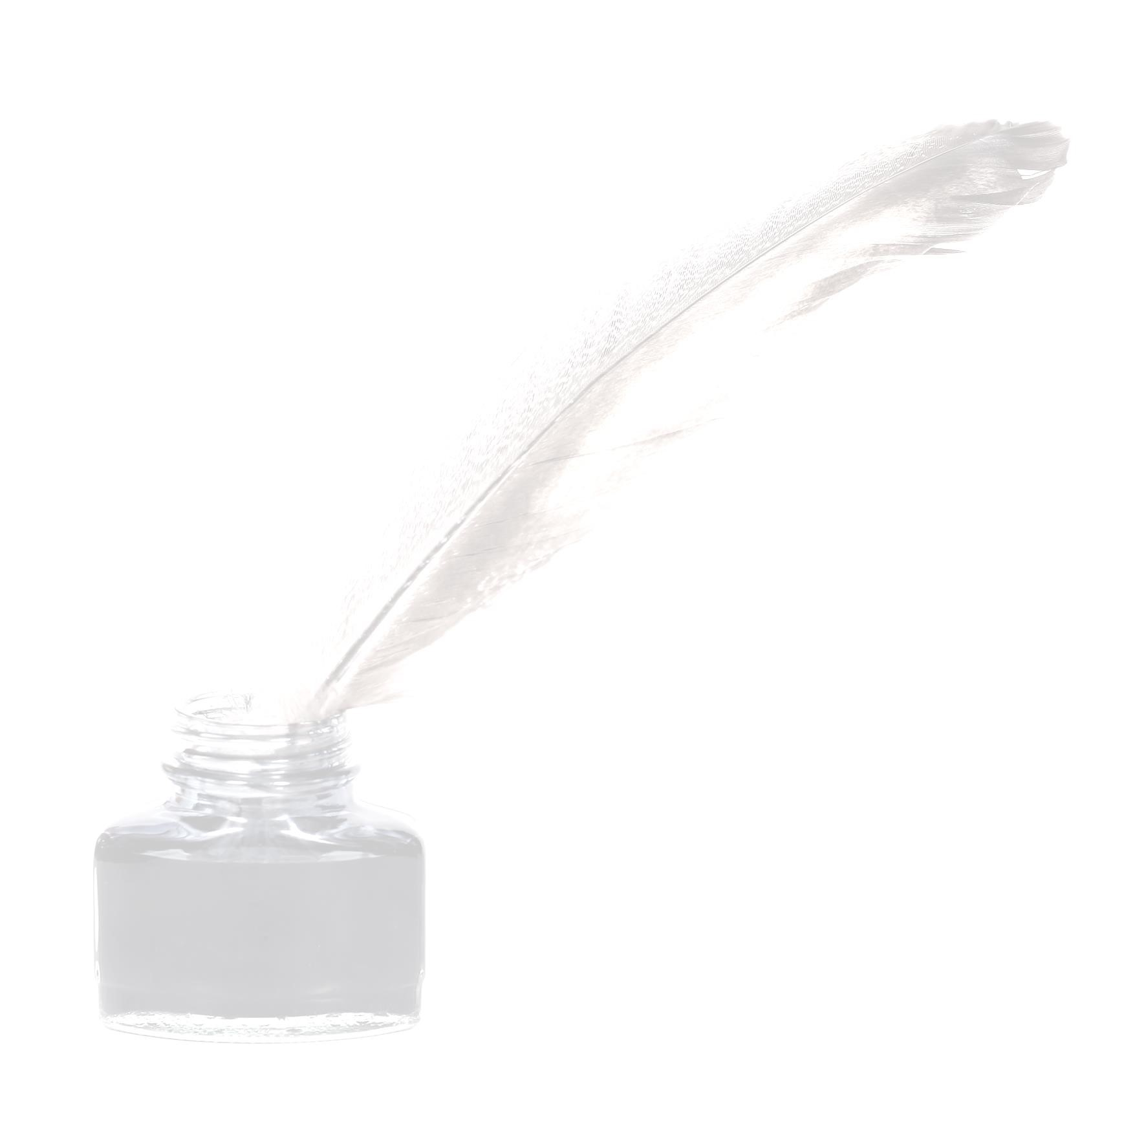

# AWARD: The winner of the competition will receive a cash award of $5,000 and have their winning submission published in the newsletters of the three county bar associations. As well, the winner will be invited to a meeting of the three county bar associations in January 2025, at which time the award will be presented, either virtually or in person.

# JUDGING: All submissions will be judged, anonymously, by a panel which includes members of the Bar Foundations for the three counties, The Judges shall apply the following criteria: importance of a timely topic, quality, style, thoroughness, and depth of research

**DEADLINE:** All submissions must be received by CCBF Executive Director Carol Walker, Cumberland County Bar Foundation, P.O. Box 2374, Vineland, NJ 08362 no later than January 1, 2025. Her email address is ccba@ccnjbar.org and her telephone number is (856) 696-5550.

**GOAL:** The goal of the competition is to recognize the importance of excellence in legal writing and to award a student enrolled in an ABA-approved law school for authoring a top-quality competition submission.

**IN HONOR OF:** The writing competition is sponsored by the Cumberland County, Gloucester County, & Salem County Bar Associations. It is in honor of the late Judge Samuel G. DeSimone, former New Jersey Superior Court Assignment Judge of Cumberland County, Gloucester County and Salem County. Judge DeSimone attended Gettysburg College and was a 1958 graduate of Georgetown University School of Law. He served the bench from his year of appointment by Governor Brendan Byrne in 1975 through his year of retirement 2000.

**HISTORY OF TOPIC:** The topic for the 2024-2025 contest is the viability of potential amendments to the United States Constitution.

Some of the more popular amendments that have recently emerged include: 1) enacting a clear Equal Rights Amendment that fully protects against gender discrimination and would include clear protections for LGBTQ+ individuals; 2) returning the constitutional right of abortion before fetal viability, a United States precedent that had been in place for more than 50 years;  and 3) a total civilian assault rifle and bump stock ban.

The idea of amending the Constitution dates back to James Madison who first introduced the Bill of Rights amending the Constitution on June 8, 1789. In 1816, Thomas Jefferson suggested in a famous letter to Samuel Kercheval that each generation should have the solemn opportunity to update the constitution thus allowing it to be handed on, with periodic repairs, from generation to generation.  
  
Constitutional Amendments have been suggested thousands of times since the Constitution was ratified, but only 27 of the 33 amendments have been approved. These included adding the Bill of Rights (passed in 1791); changing the way the President and Vice President are elected; abolishing slavery; preventing state governments from discriminating against any person; guaranteeing the right to vote to all citizens regardless of race or sex; giving the federal government the power to collect an income tax; providing for the direct election of Senators; and both outlawing (in 1919) and then legalizing (in 1933) the production and distribution of alcohol.

**TOPIC:** Discuss and draft a 28th Amendment to the United States Constitution.