**FOURTH ANNUAL JUDGE SAMUEL G. DESIMONE**

**MEMORIAL LEGAL WRITING COMPETITION 2023-2024**

The Cumberland County, Gloucester County, & Salem County Bar Associations are pleased to jointly announce the 2023-2024 legal writing competition in honor of the late Judge Samuel G. DeSimone, former New Jersey Superior Court Assignment Judge of Cumberland County, Gloucester County and Salem County. In so doing, the three county bar associations recognize the importance of excellence in legal writing and seek to award a student enrolled in an ABA-approved law school for authoring a top-quality competition submission.

Judge Samuel G. DeSimone was born March 31, 1931, in Paulsboro, New Jersey. He attended the Paulsboro School System and was a 1948 graduate of Paulsboro High School. Judge DeSimone attended Gettysburg College and Georgetown University School of Law in Washington, D.C., where he was awarded a Doctor of Jurisprudence Degree in 1958. In 1975, he was appointed to the Superior Court Bench by Governor Brendan Byrne. He served in every division of the Superior Court of New Jersey and in 1982 was appointed the first Assignment Judge of Cumberland, Gloucester and Salem Counties, known as Vicinage XV, where he served in that capacity until his retirement in the year 2000. He was the recipient of the V. Robert Payant Award for Excellence in Judicial Teaching.

# ELIGIBILITY

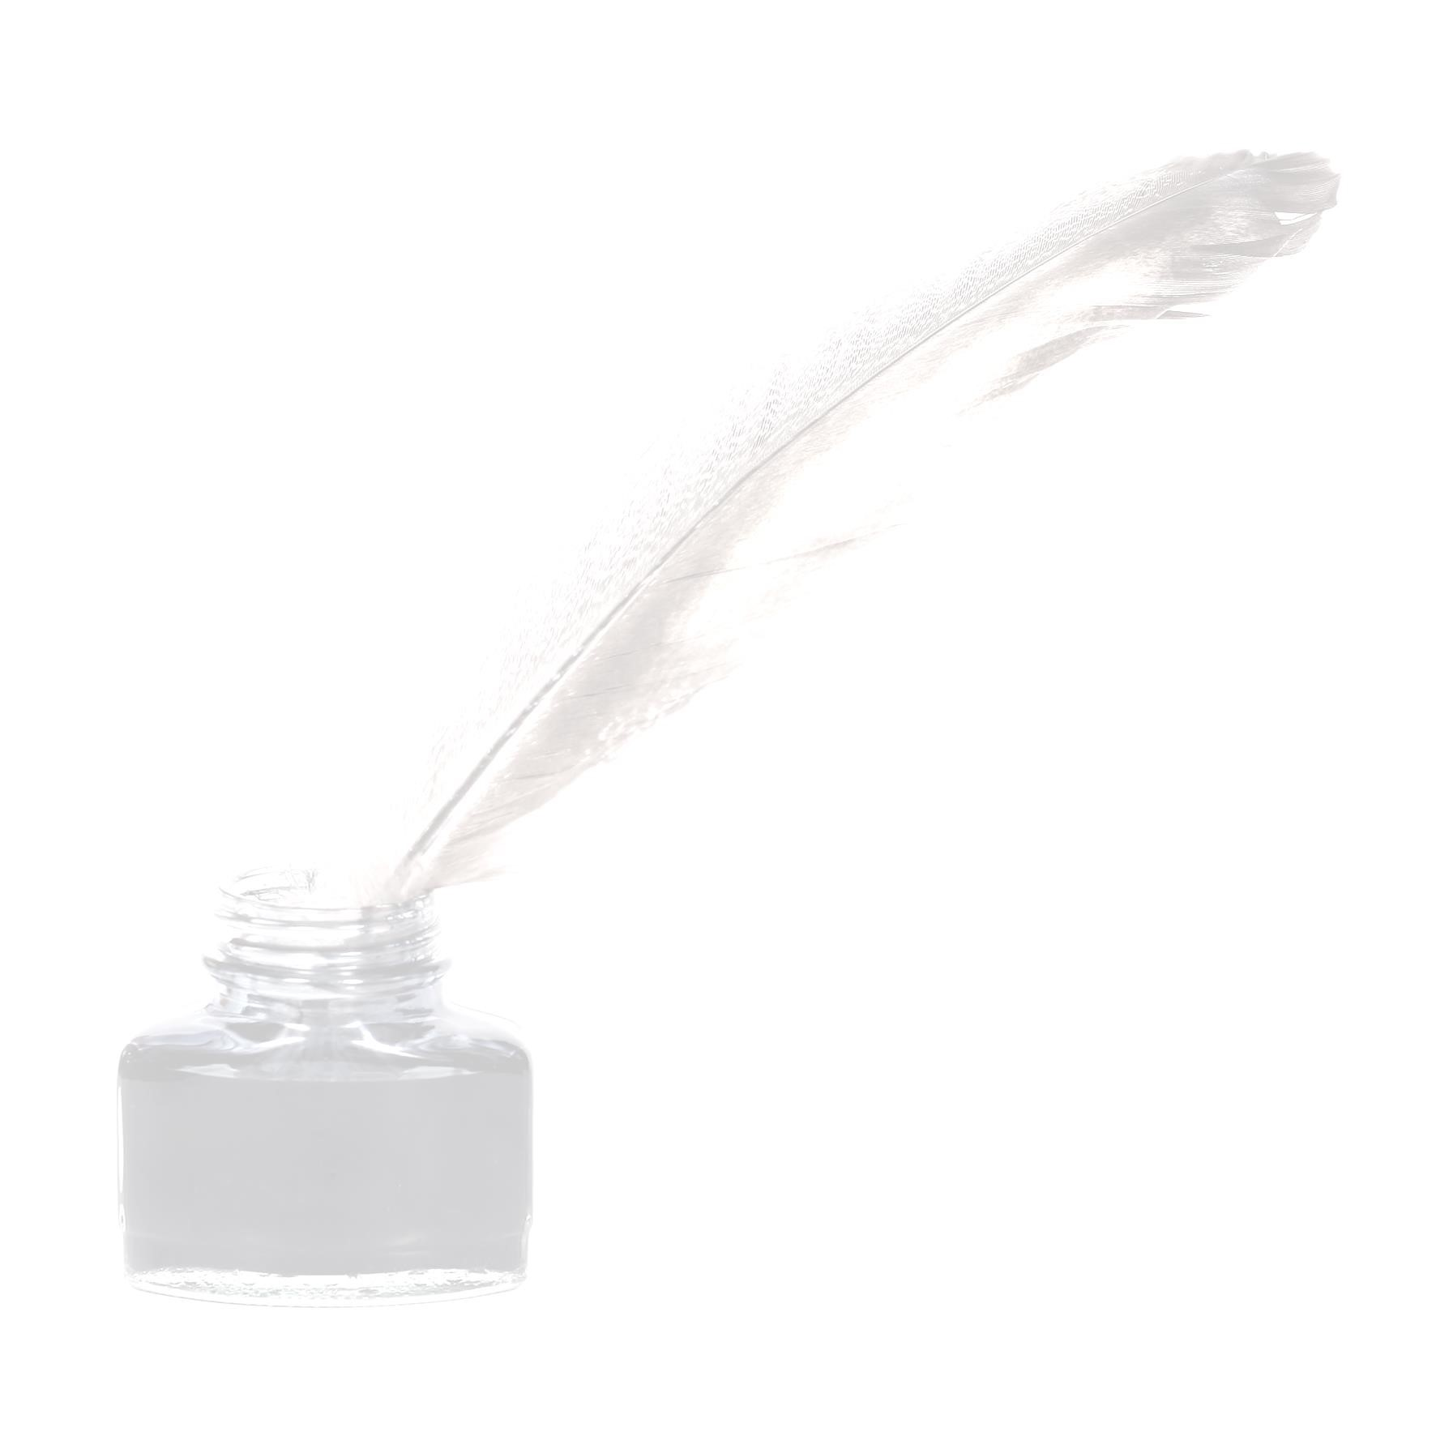The Judge Samuel G. DeSimone Legal Writing Competition is open to full-time and part-time law students who are enrolled in the 2023-2024 academic year in an accredited Law School, who reside in Burlington, Ocean, Atlantic, Cape May Cumberland, Salem, Gloucester, and Camden counties. Students must be or have been in good standing at their institutions. The submission must be original writings and may not have been previously published in a law review or journal. The submission also may not have been submitted for any other competition during the time when it is under consideration for this competition. The submission must be the work of one author alone; joint submissions will not be considered.

**TOPIC**

Candidates may submit a law review quality submission. The subject matter of the 2023-2024 DeSimone Law School Essay Competition pertains to the nature and extent of the pardon power granted to the president of the United States of America. Specifically, Article II, Section 2, Clause 1 of the United States Constitution provides: **“*The President … shall have Power to grant Reprieves and Pardons for Offences against the United States, except in Cases of Impeachment.”*** Explain whether a sitting president has the constitutional power to pardon himself/herself of federal criminal convictions and any related punishment.

# AWARD

**The author of the first-place submission will receive a cash award of $4,000** and the publication of the winning submission in the three county bar associationnewsletters and on their websites. The winner of the first-place award will be invited to a meeting of the three county bar associations in January 2024, at which time the award will be presented, either virtually or in person.

# JUDGING

Trustees and officers of the three county bar foundations will evaluate the submissions for the purpose of granting the awards applying the following established criteria: importance of a timely topic, quality, style, thoroughness and depth of research. The submissions will be judged anonymously.

All submissions must be received by CCBF Executive Director Carol Walker, Cumberland County Bar Foundation, P.O. Box 2374, Vineland, NJ 08362 no later than December 31, 2023. Her email address is ccba@ccnjbar.org and her telephone number is (856) 696-5550.