**THIRD ANNUAL JUDGE SAMUEL G. DESIMONE**

**MEMORIAL LEGAL WRITING COMPETITION**

**2023**

The Cumberland County, Gloucester County and Salem County Bar Associations are pleased to jointly announce the 2023 legal writing competition in honor of the late Judge Samuel G. DeSimone, former New Jersey Superior Court Assignment Judge for Cumberland, Gloucester and Salem Counties (known as Vicinage XV). In so doing, the aforementioned County Bar Associations recognize the importance of quality legal writing and seek to award a student enrolled in an ABA-approved law school for authoring the best competition submission.

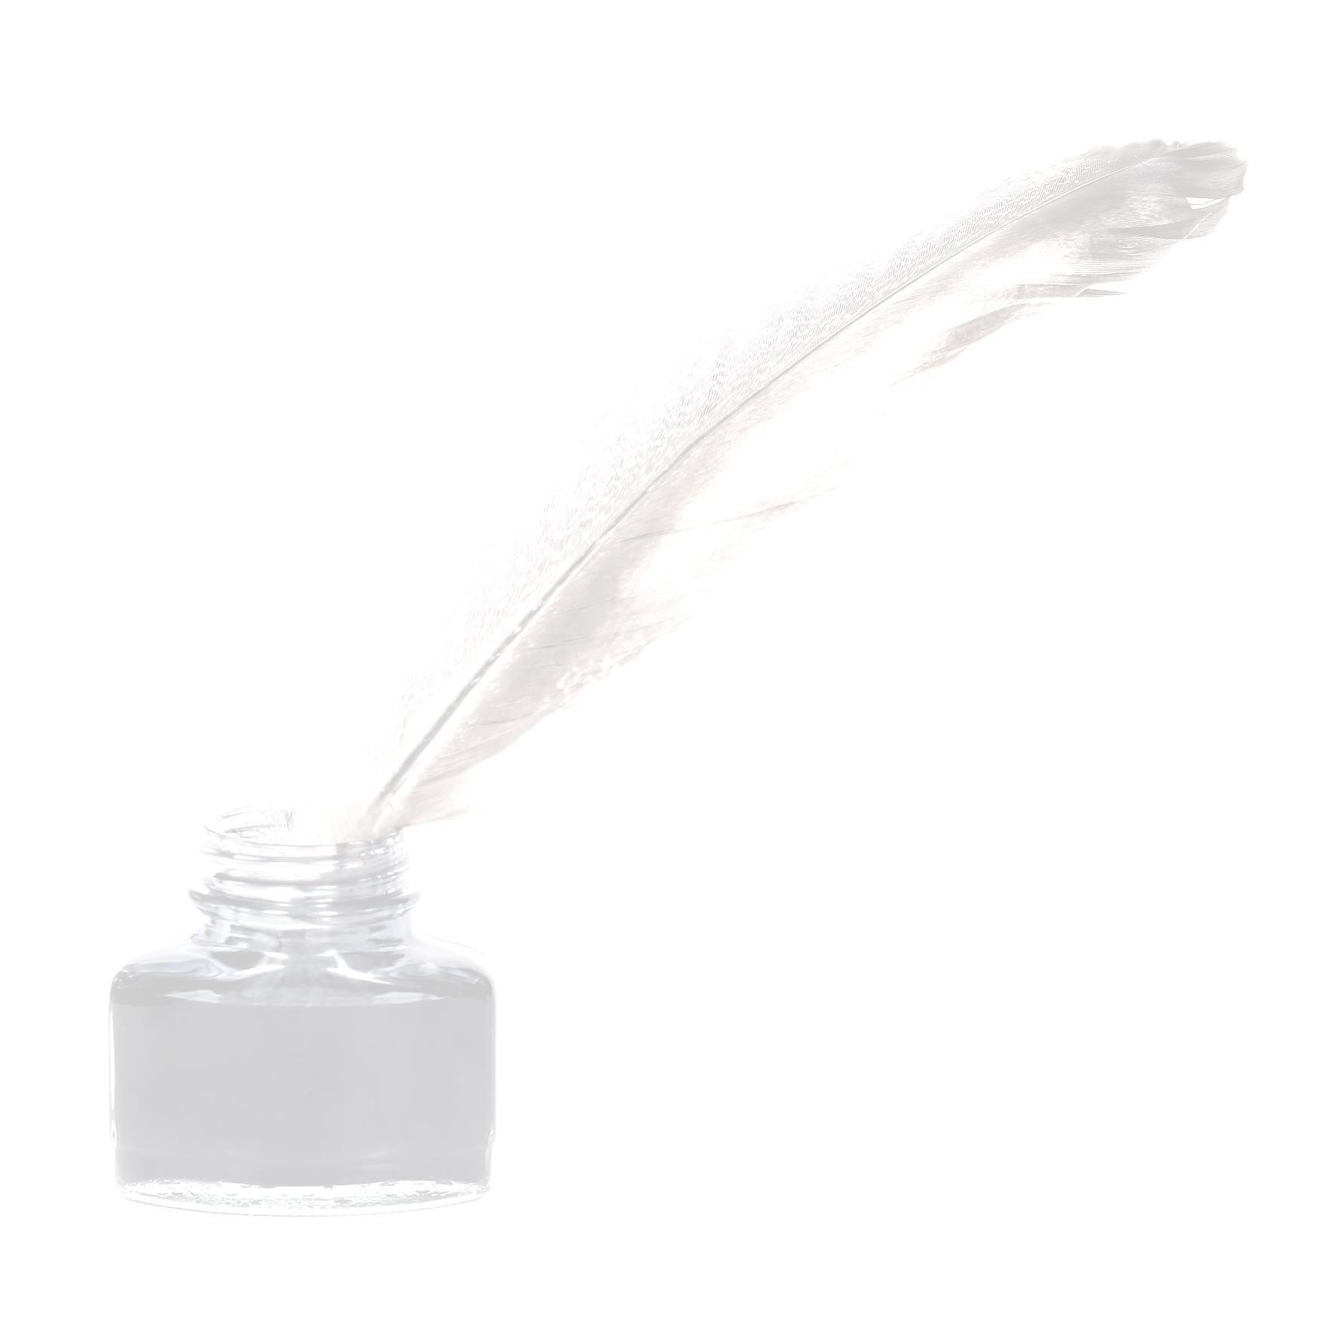Judge Samuel G. DeSimone was born March 31, 1931 in Paulsboro, New Jersey. He attended the Paulsboro public school system and was a 1948 graduate of Paulsboro High School. Judge DeSimone attended Gettysburg College in Gettysburg, PA and Georgetown University School of Law in Washington, D.C., where he was awarded a Juris Doctor degree in 1958. In 1975, he was appointed to the bench of the Superior Court by Governor Brendan Byrne. He served in every Division of the Superior Court of New Jersey. In 1982, he was appointed as the first Assignment Judge of Vicinage XV and served in that capacity until his retirement in 2000. He was a recipient of the V. Robert Payant Award for Excellence in Judicial Teaching.

# ELIGIBILITY

The Judge Samuel G. DeSimone Legal Writing Competition is open to full-time and part-time law students who are enrolled in the 2022-2023 academic year at an accredited law school. Applicants must reside in Burlington, Ocean, Atlantic, Cape May, Cumberland, Salem, Gloucester or Camden Counties. Students must be in good academic standing for the current law school term. The submission must be an original writing and must not have been previously published in a law review/journal. The submission must also not have been submitted for any other competition during the time when it is under consideration for this competition. The submission must be the work of one author alone; joint submissions will not be considered.

**TOPIC**

Candidates should provide a submission of law review quality on the following topic: “**The number of Justices on the United States Supreme Court has changed six times before settling at the present total of nine in 1869. Given the recent actions of the current Court, which has overturned long-standing legal precedent, explain the pros and cons of expanding the number of Justices from nine to eleven.”**

# AWARD

**The author of the first-place submission will receive a cash award of $4,000.00** ($1,000.00 from each of the County Bar Foundations of Vicinage XV and $1,000.00 from John DeSimone, Esq.) and the publication of their submission in each of the County Bar Associations’newsletters and on their websites. The winner will also be invited to a meeting of one of the County Bar Associations of Vicinage XV in early summer 2023 to receive their award.

# JUDGING

Trustees and officers of the County Bar Foundations of Vicinage XV will evaluate the submissions for the purpose of granting the awards by applying the following established criteria: quality, style, thoroughness and depth of research. The submissions will be judged anonymously.

All submissions must be received by Cumberland County Bar Foundation Executive Director Carol Walker Cumberland County Bar Foundation P.O. Box 2374 Vineland, NJ 08362 no later than May 19, 2023. Ms. Walker’s e-mail address is ccba@ccnjbar.org and her telephone number is (856) 696-5550.